**VISVESVARAYA TECHNOLOGICAL UNIVERSITY**

**“JnanaSangama”, Belgaum -590014, Karnataka.**



**PROJECT WORK-1 REPORT**

**on**

**PROJECT TITLE**

***Submitted by***

**TUSHAR A PAI (1BM19CS174)**

**TRISHUL M (1BM19CS173)**

**TARUN SRIRAM DAMMU (1BM19CS171)**

**VASANTH KUMAR T (1BM19CS180)**

***Under the Guidance of***

|  |  |
| --- | --- |
| **Rekha G S**  **Assistant Professor, BMSCE** |  |

***in partial fulfillment for the award of the degree of***

**BACHELOR OF ENGINEERING**

***in***

**COMPUTER SCIENCE AND ENGINEERING**



**B.M.S. COLLEGE OF ENGINEERING**

**(Autonomous Institution under VTU)**

**BENGALURU-560019**

**Sep-2020 to Jan-2021**

**B. M. S. College of Engineering,**

**Bull Temple Road, Bangalore 560019**

(Affiliated To Visvesvaraya Technological University, Belgaum)

**Department of Computer Science and Engineering**



**CERTIFICATE**

This is to certify that the project work entitled “**AGRICULTURAL HELP DESK**” carried out by **TUSHAR A PAI (1BM19CS174), TRISHUL M (1BM19CS173), TARUN SRIRAM DAMMU (1BM19CS171) AND VASANTH KUMAR T (1BM19CS180)** who are bonafide students of **B. M. S. College of Engineering.** It is in partial fulfillment for the award of **Bachelor of Engineering in Computer Science and Engineering** of the Visveswaraiah Technological University, Belgaum during the year 2020-2021. The project report has been approved as it satisfies the academic requirements in respect of **Project Work-1 (19CS3PWPW1)** work prescribed for the said degree.

Signature of the Guide                 Signature of the HOD

Rekha G S Dr. Umadevi V

Assistant Professor Associate Prof.& Head, Dept. of CSE

BMSCE, Bengaluru BMSCE, Bengaluru

External Viva

Name of the Examiner                                                                                       Signature with date

1._____________________________ ________________________

2. _____________________________ _________________________

**B.M.S. College of EngineerinG**

**DEPARTMENT OF COMPUTER SCIENCE AND ENGINEERING**



**DECALARATION**

We, TUSHAR A PAI (1BM19CS174), TRISHUL M (1BM19CS173), TARUN SRIRAM DAMMU (1BM19CS171), VASANTH KUMAR T (1BM19CS180), students of 3rd Semester, B.E, Department of Computer Science and Engineering, B. M. S. College of Engineering, Bangalore, hereby declare that, this Project Work-1entitled "AGRICULTURAL HELP DESK" has been carried out by us under the guidance of Rekha G S, Assistant Professor, Department of CSE, B. M. S. College of Engineering, Bangalore during the academic semester Sep-2020-Jan-2021.

We also declare that to the best of our knowledge and belief, the development reported here is not from part of any other report by any other students.

Signature

TUSHAR A PAI (1BM19CS174)

TRISHUL M (1BM19CS173)

TARUN SRIRAM DAMMU (1BM19CS171)

VASANTH KUMAR T (1BM19CS180)

**Introduction**

Website development for “Agricultural Help Desk”

This online submission system supports

Farmers and Agricultural Enthusiasts

**Functionalities under the main page**

1. A page which gives information about different crops.

2. A page which gives information about some of the Agricultural Events held in India.

3. A page for frequently asked questions.

4. A page which gives information about some of the Agro Jobs in India.

5. A page which gives information about some of the Agricultural Schemes in India.

6. A contact us page which takes any enquiry related to agriculture. This page also provides the information of the organization which has provided the website.

7. An about us page will show the goals which the organization wants to achieve by developing this website.

2. Design Layouts: Screen Shots of Webpages

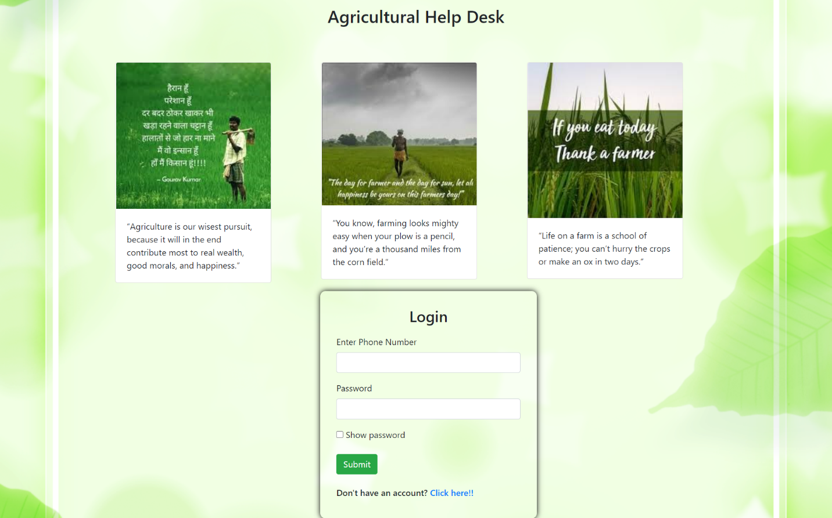2.1: Login Webpage

**2.2: Sign Up Page**

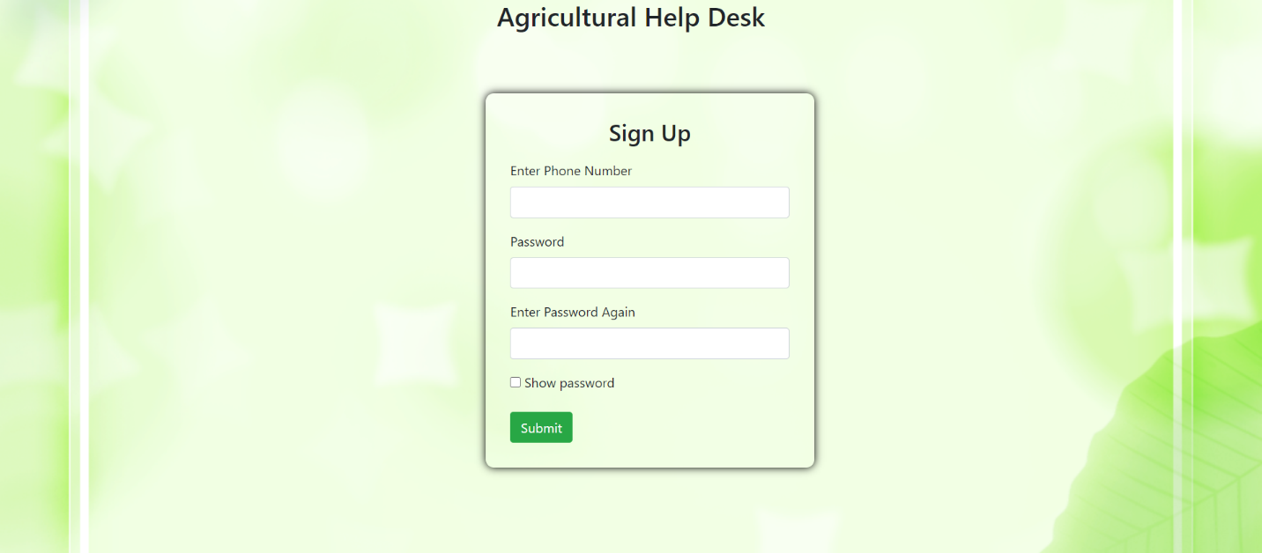

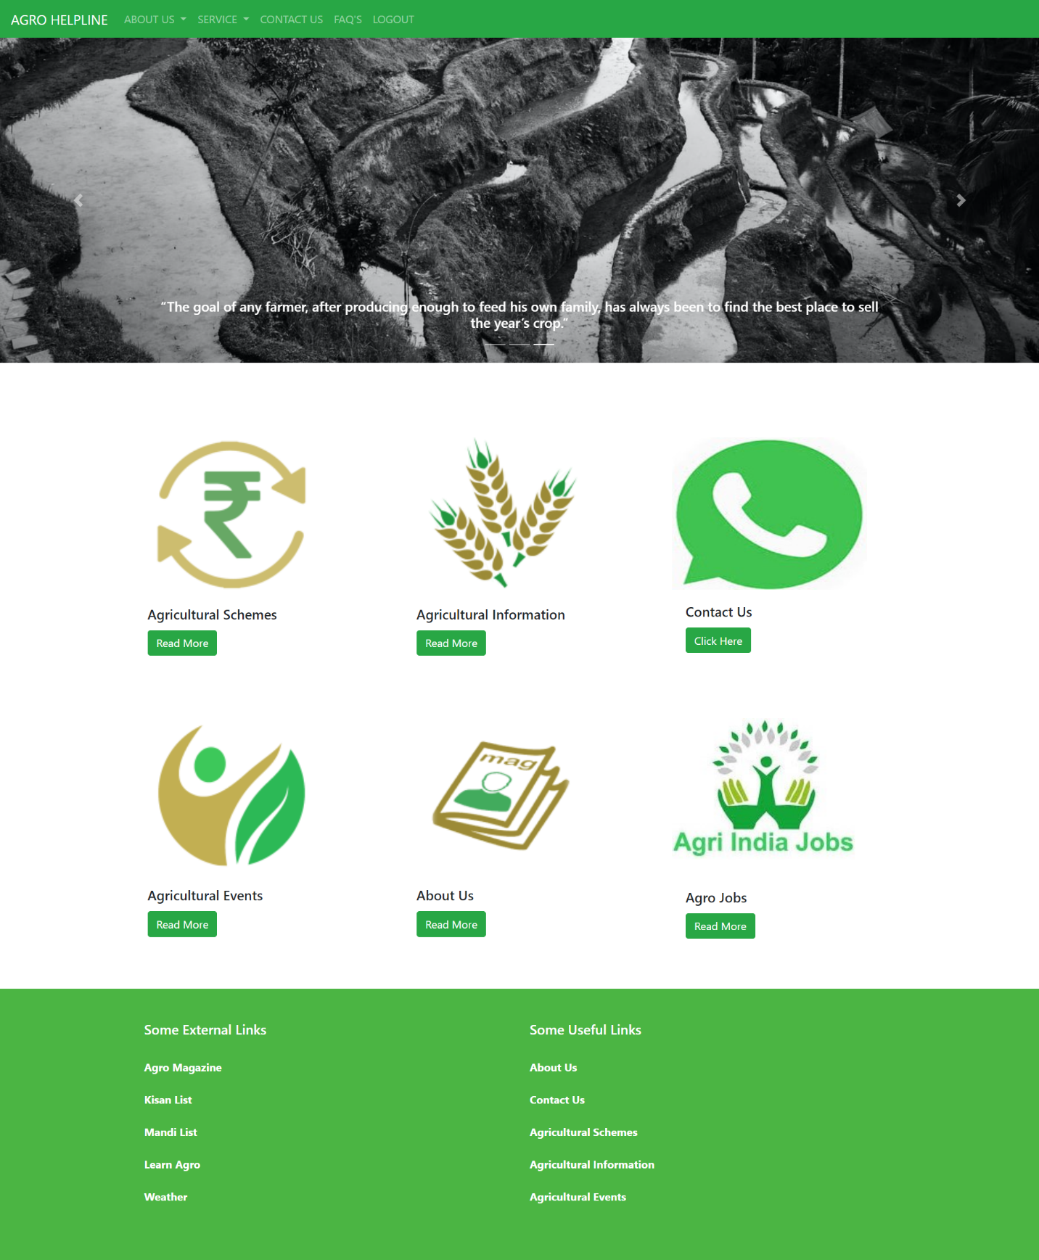**2****.3: Main Page**

**2.4: Agricultural Schemes Page**

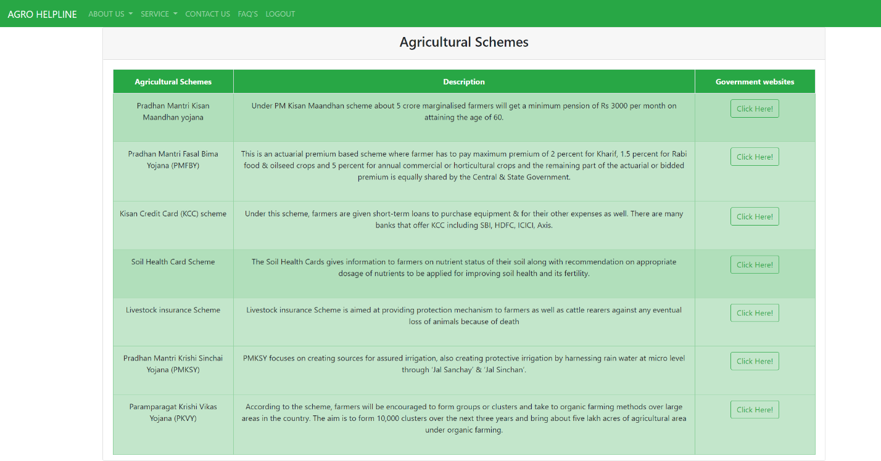

**2.5: FAQ’S Page**

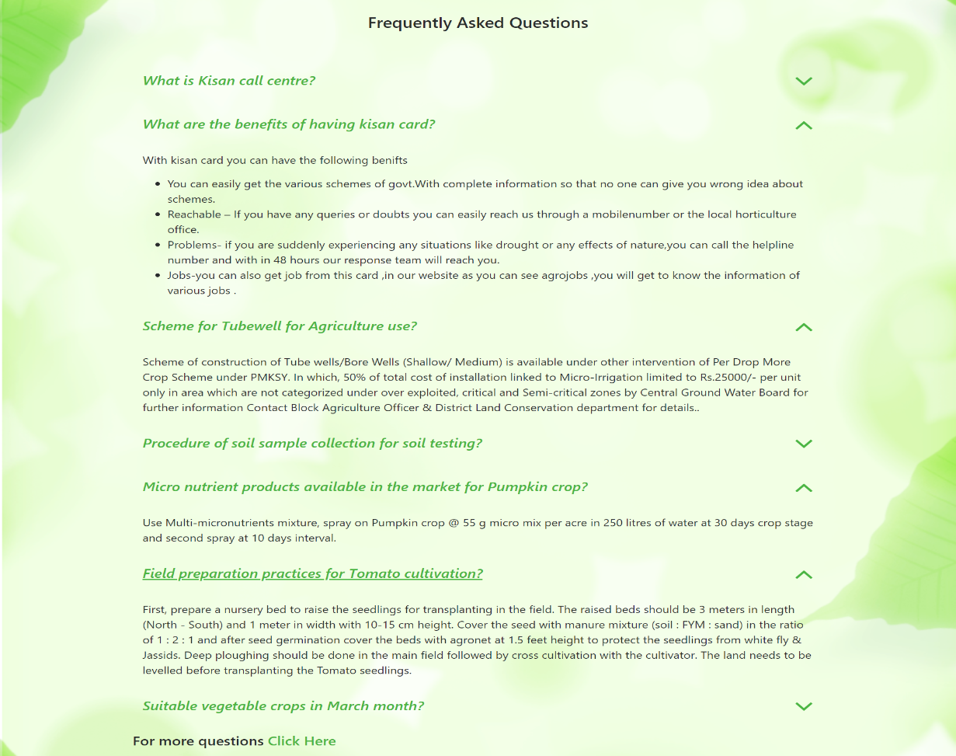

**2.6: Agricultural Events Page**

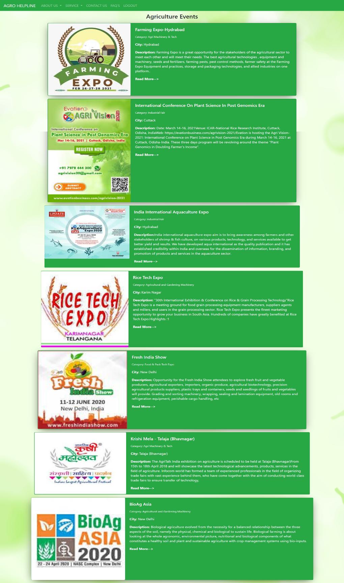

**2.7: Agro Jobs Page**

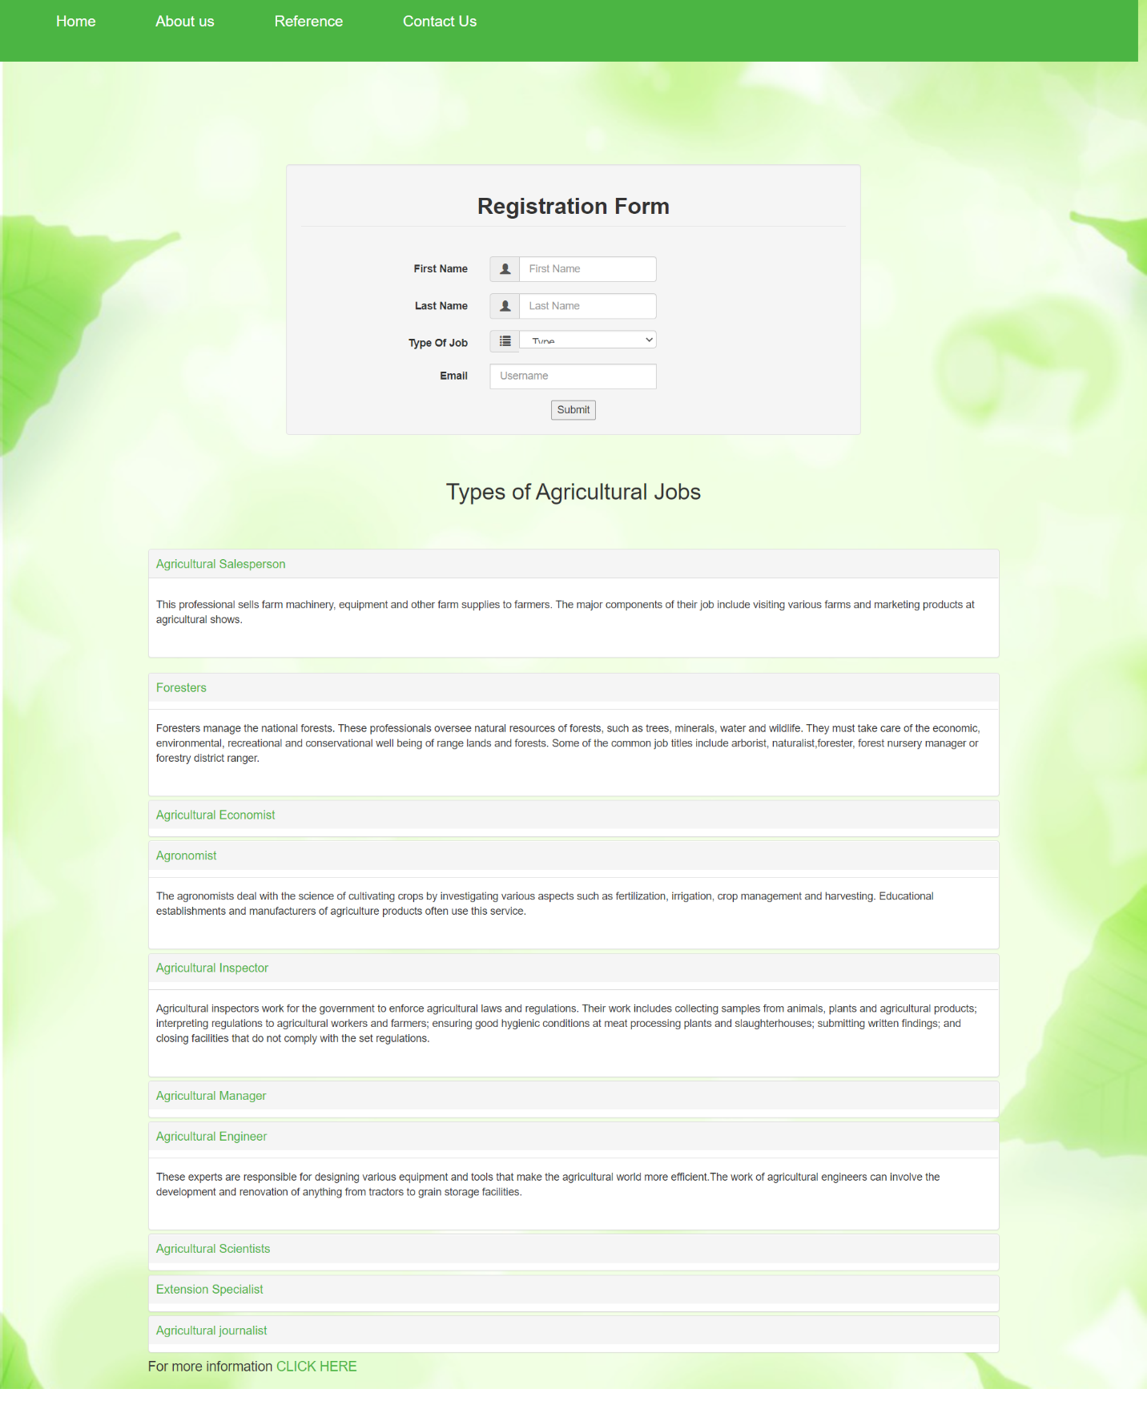

**2.8: Agricultural Information Page**

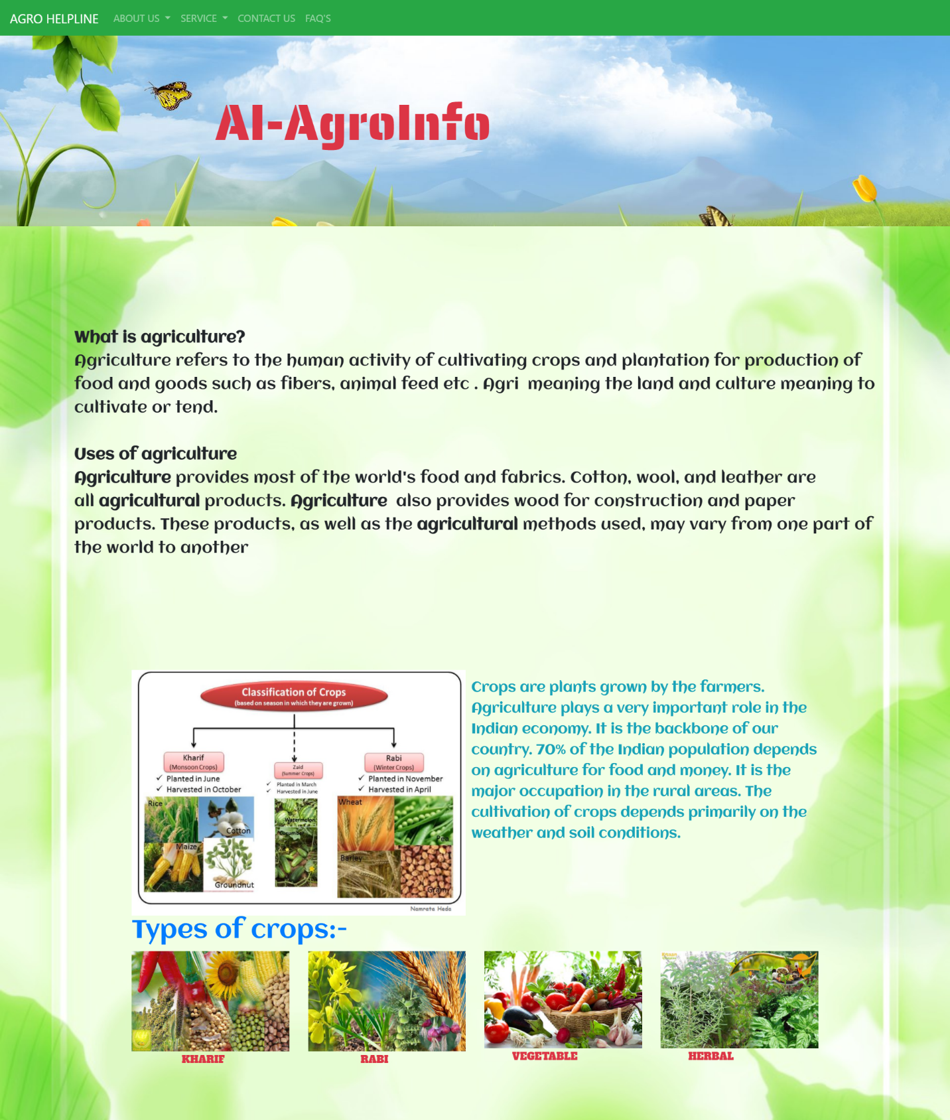

**2.8.1: Agricultural Information Page (Kharif Crops)**

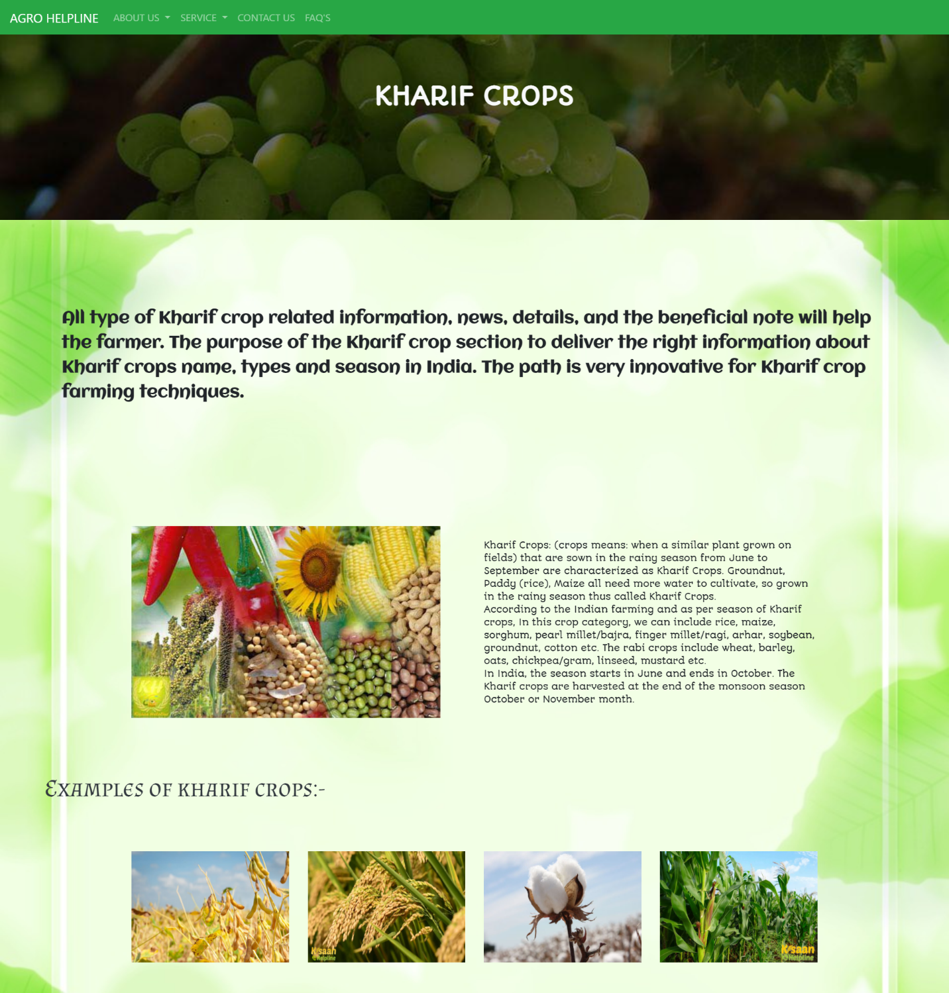

**2.8.2: Agricultural Information Page (Rabi Crops)**

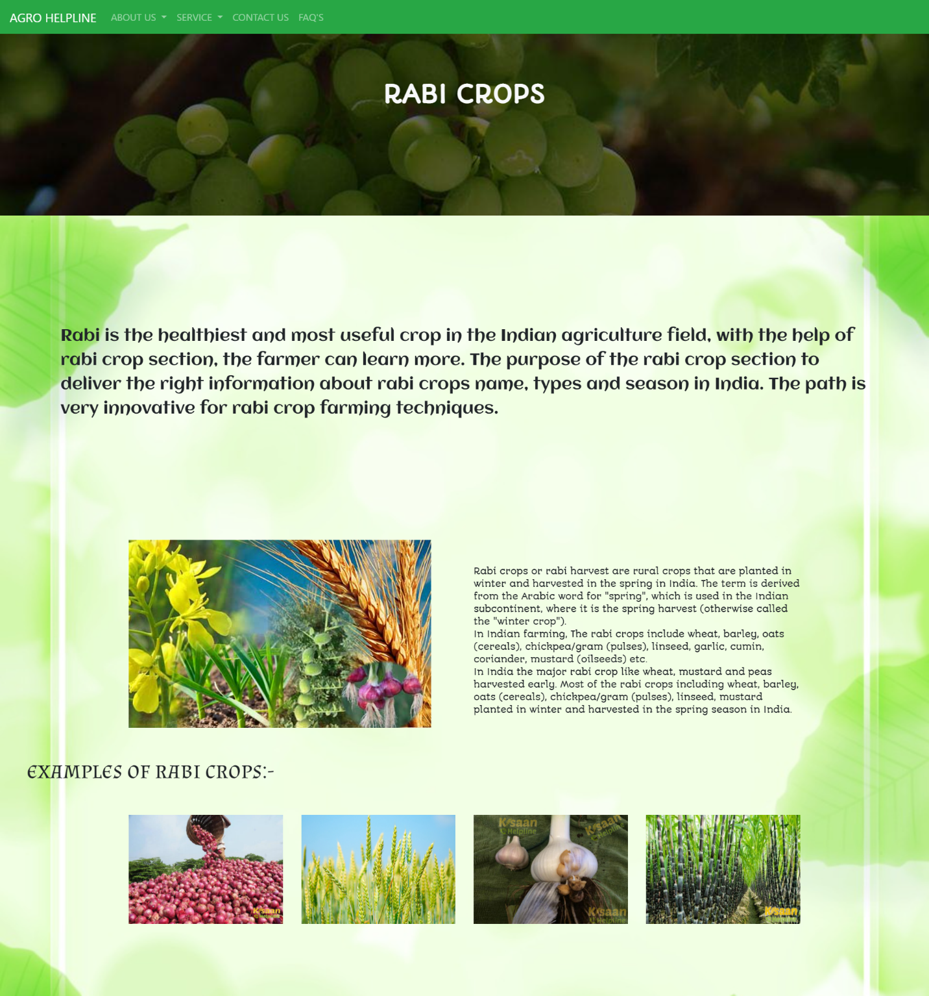

**2.8.3: Agricultural Information Page (Vegetable Crops)**

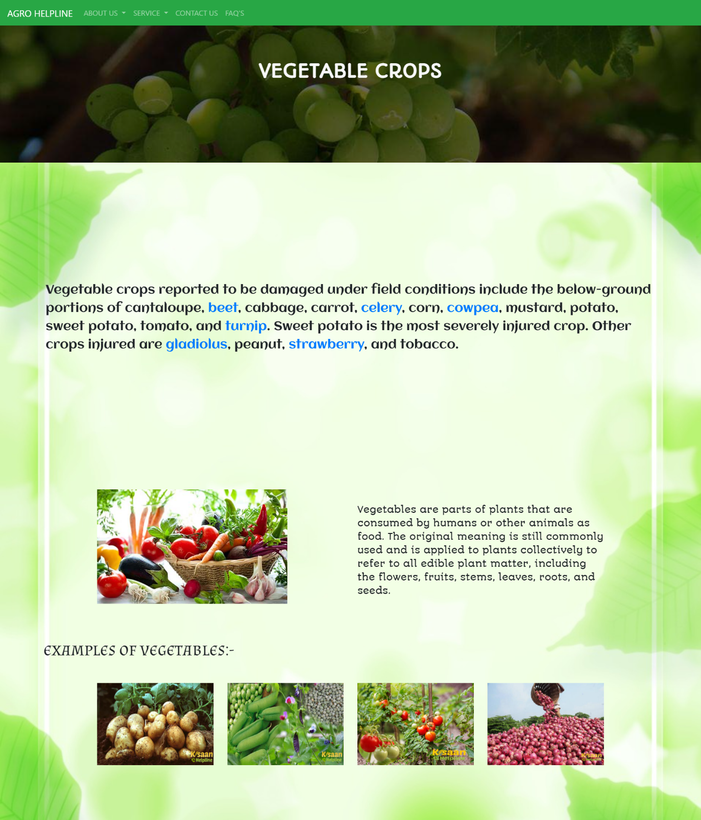

**2.8.4: Agricultural Information Page (Herbal Crops)**

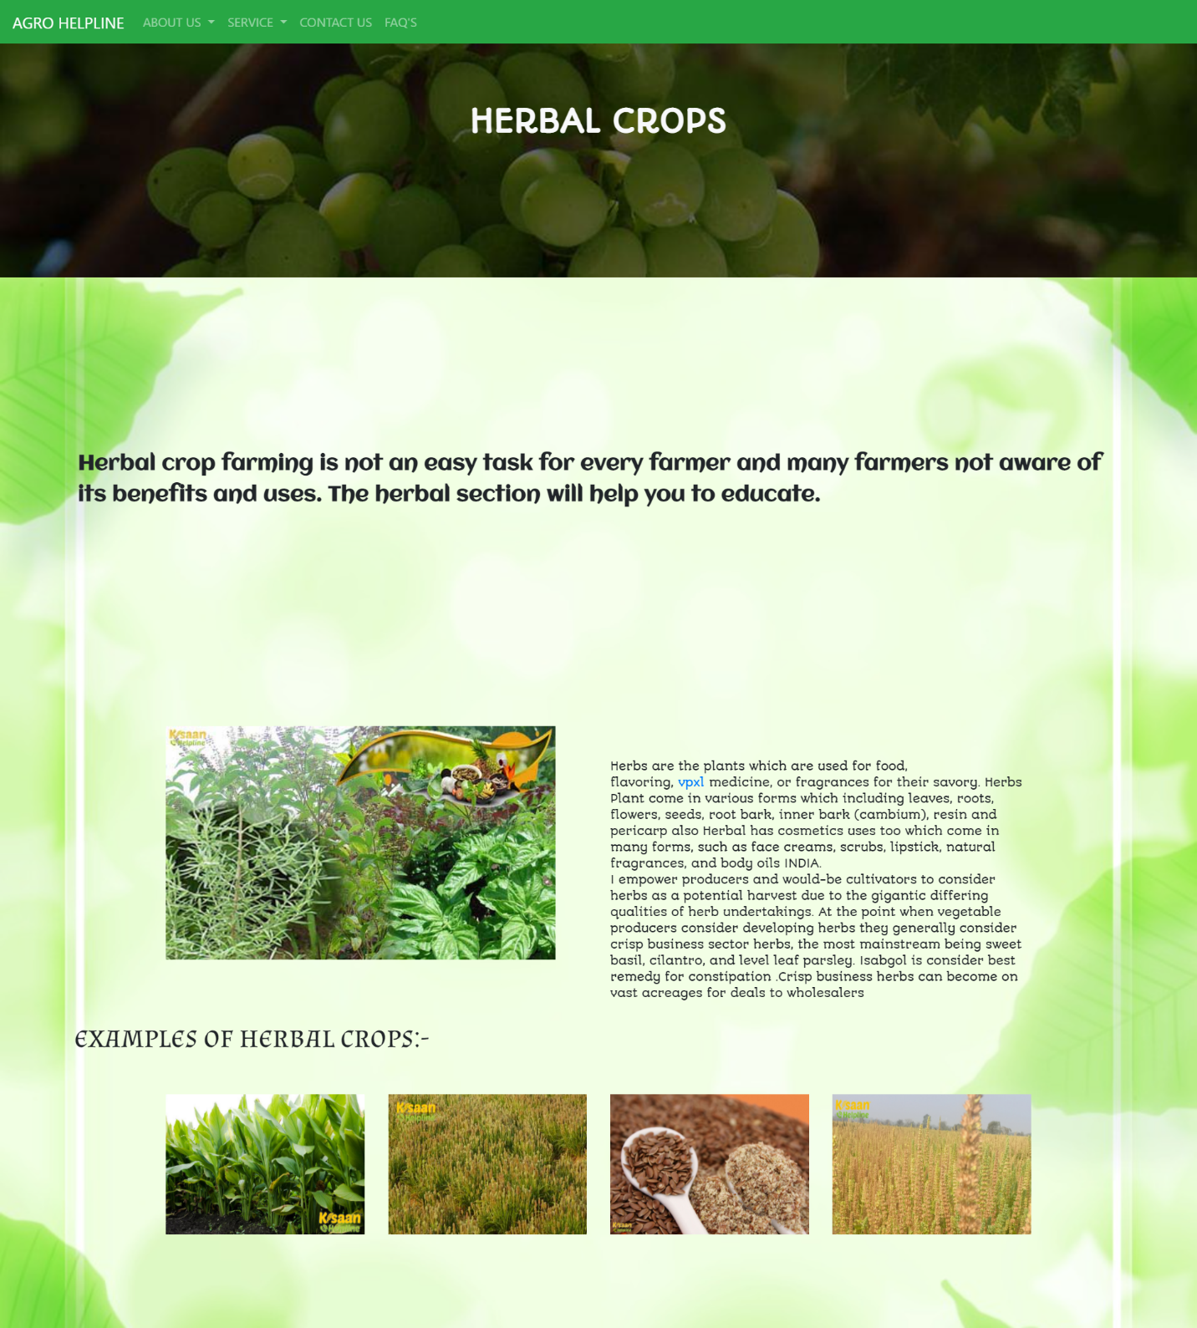

**2.9: About Us Page**

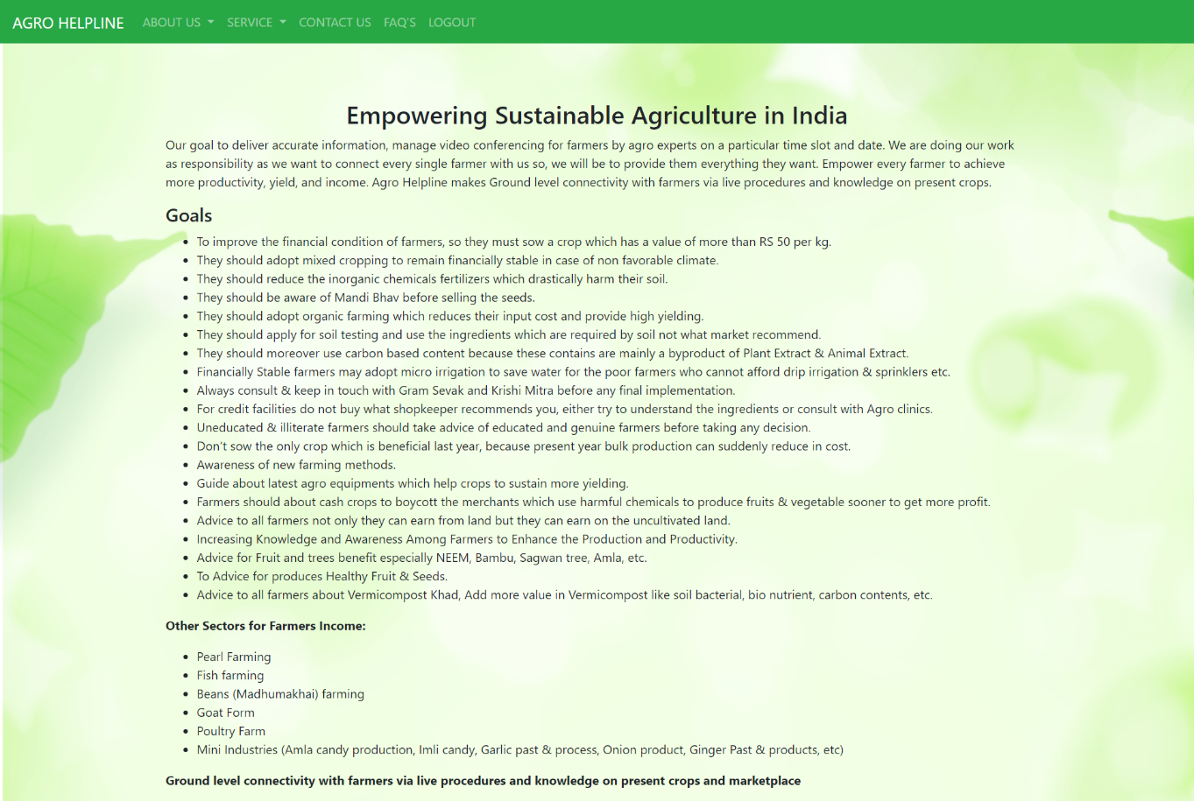

**2.10: Contact Us Page**

